A Level Geography Itinerary to Platja D’Aro, Costa Brava, Spain.

Geofieldwork Ltd and SunSports Tours and Tournaments

Geofieldwork Ltd - Barry Cullimore. 07496 737066
office@geofieldworkltd.com

SunSports Tours and Tournaments - James Langdon-Davies. 0034 650 930 517
info@sunsports-spain.com

Day One

Arrival / Bournemouth or Girona airport and airport transfer OR direct coach travel from UK.
Settle into the hotel in Platja D’Aro. Evening Meal. Walk to the beach and some short, fun familiarisation activities on the beach including some basic Spanish language!

Day Two - Coastal Processes, Landforms and Management.

- AM - walk from Platja D’Aro to Sant Antoni de Calonge studying a wide range of coastal processes and erosional and depositional landforms.
- Skills covered include field sketching, sampling strategies, qualitative and quantitative data collection.
- Lunch - visit a supermarket or cafe in Sant Antoni.
- PM - studying coastal management along the seafront of Sant Antoni de Calonge.
- Skills covered include sampling strategies, field sketching and sketch maps, quantitative data collection, GIS.
- Coach journey back to hotel.
- Evening meal
- Evening session for one hour to collate, analyse and conclude the coastal management study.

Day Three - Urban Regeneration Case Study in Girona, the Capital of Catalonia.

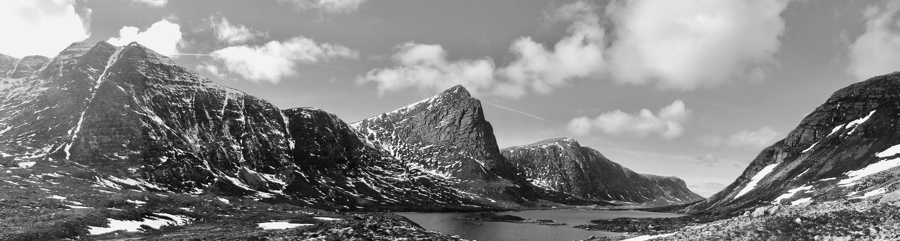
- AM - coach to Girona. Initial exploration and introduction to the history of Girona. Fieldwork studying urban regeneration in the Old Quarter in the 1990’s and early 2000’s. Skills covered will include sampling strategies, qualitative and quantitative data collection.
- Lunch - visit a supermarket or cafe in the Old Quarter.
- PM - Game of Thrones tour and studying how “set-jetting” is leading to further economic and cultural regeneration in Girona. (Girona was used to film the Kings Landing and Braavos scenes in GOT)
- Coach journey back to Hotel.
- Evening meal.
- Evening session for one hour to collate, analyse and conclude study.

Day Four - Sand Dune Ecosystems and Tectonic Hazards.

- AM - early breakfast and coach to Olot, walking tour around Croscat Volcano and a visit to the quarry to study the geology of the volcano. Visit to the town of Olot and the Volcano Visitor Centre.
- Lunch - visit a supermarket or cafe in Olot.
- PM - coach departs Olot and stops at Sant Joan les Fonts. Short walking tour to see the lava flows and exposures of columnar basalt in the river valley.
- Coach continue to Gola de Ter, near Toroella de Montgri. Short study of sand dune succession and management.
- Coach journey back to hotel.
- Evening meal.
- Evening session for one hour to use ARCGIS to do a virtual volcanic hazard mapping exercise.

Day Five

- Depart Platja D’Aro - coach back to Airport. Optional waterpark / tour of Barcelona City / Football Stadium (additional costs)

